Q1)

In this question we used a permanent magnet DC motor whicch is fed from a three-phase full bridge thyristor rectifier. Mechanical load driven by the motor is fixed at 24Nm. Other neccessary motor data is al follows:

* Field Type: Permanent Magnet
* Armature resistance, Ra = 10 Ω
* Armature inductance, La = 0.01 H
* Back-emf Constant: 0.3 V/rpm
* Motor Inertia: 0.4 kgm2

And the system parameters are:

* Thyristor forward voltage, Vf = 0.8 V
* Thyristor on resistance, Ron = 20 mΩ
* Source inductance, Ls = 100 µH
* Source resistance, Rs = 100 m

We are required to design a speed controlled rectifier which determines the proper firing angle for desired speed value. In order to achieve this task, we used a closed loop PI controller. The schematic of the circuit is as in Figure 1.

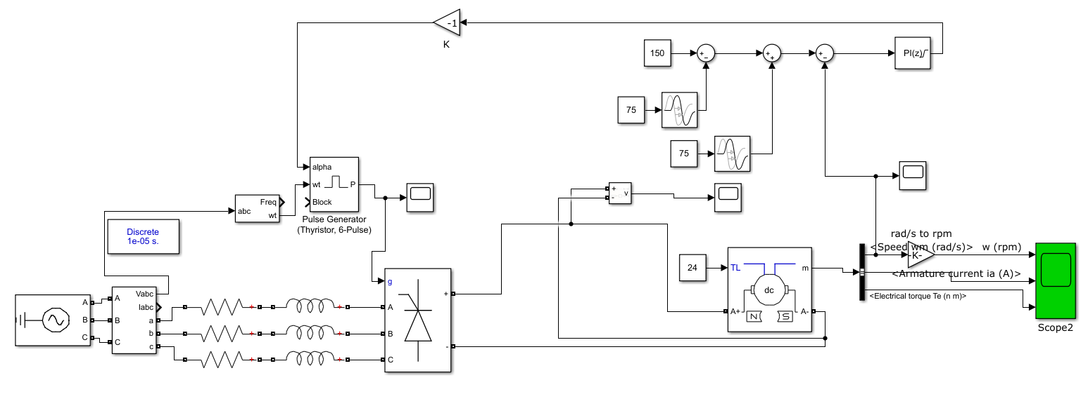

Figure 1: Circuit schematic of the first question.

The process of the controller starts with the measurement of the speed of the motor. Then, we substract this value from the desired speed value. The result of this equation is the input of the PI controller. The output of the controller then reversed into a negative of its value in order to arrange the firing angle with respect to difference of the speed values. The transport delay blocks are used in order to change the desired speed values over time as you can see from the plots below.

The methodology behind this design is that, if the motor runs faster than its desired value, the firing angle will increase and the average of the voltaage on the motor will decrease. This leads a speed drop on the motor. Moreover, if the speed value is lower than the desired speed, the firing angle will decrease and the average voltage of the motor and the speed of the motor will increase.

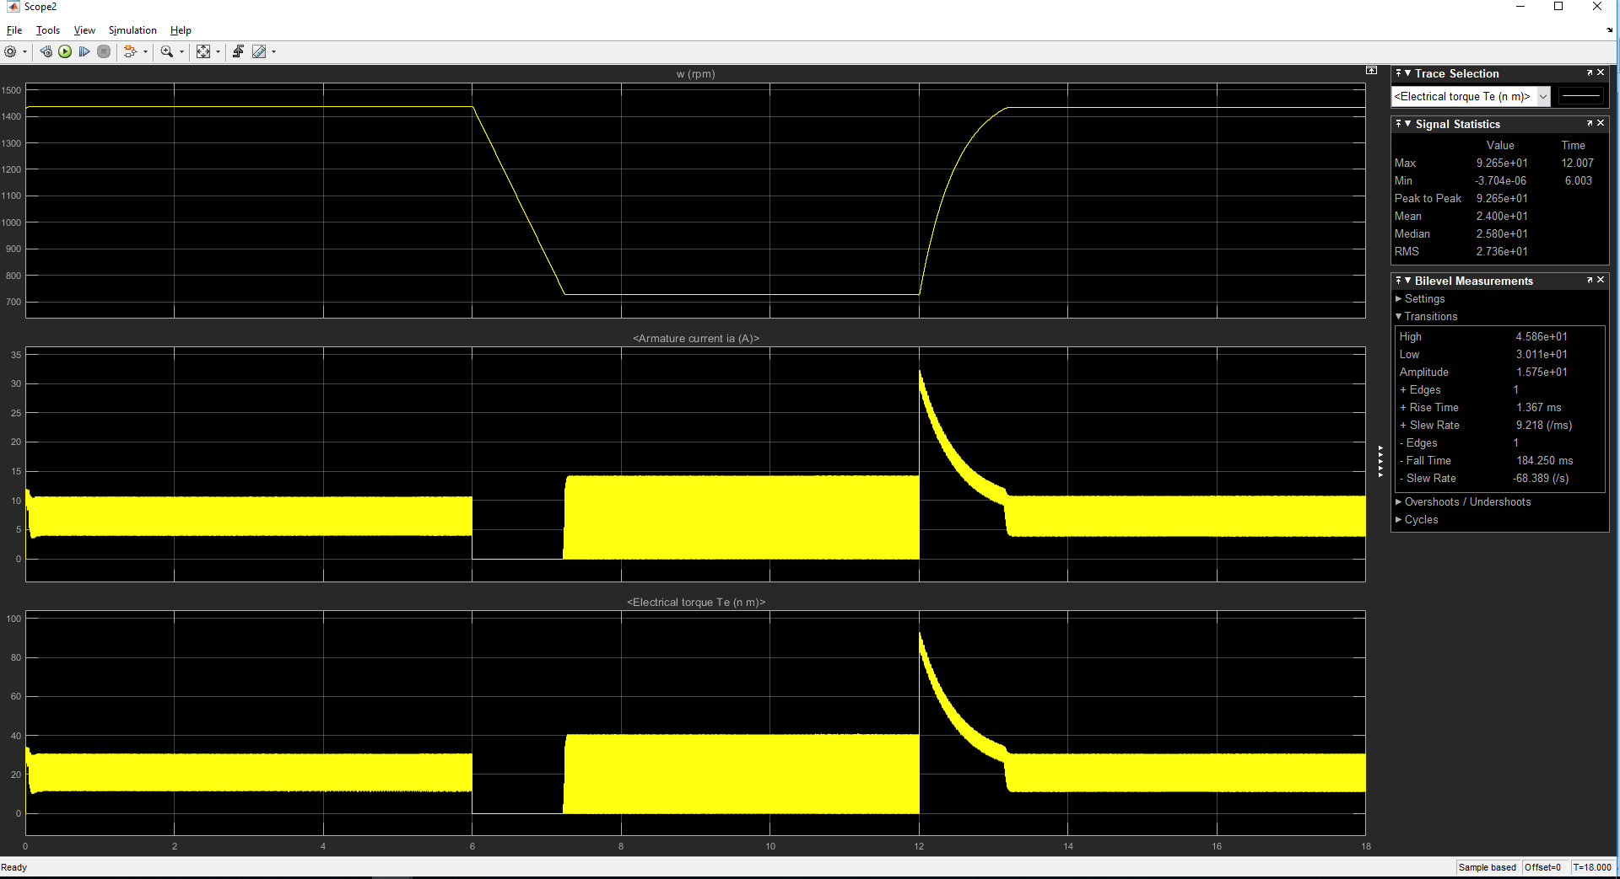

Figure 2: Speed(rpm), armature current and torque graph.

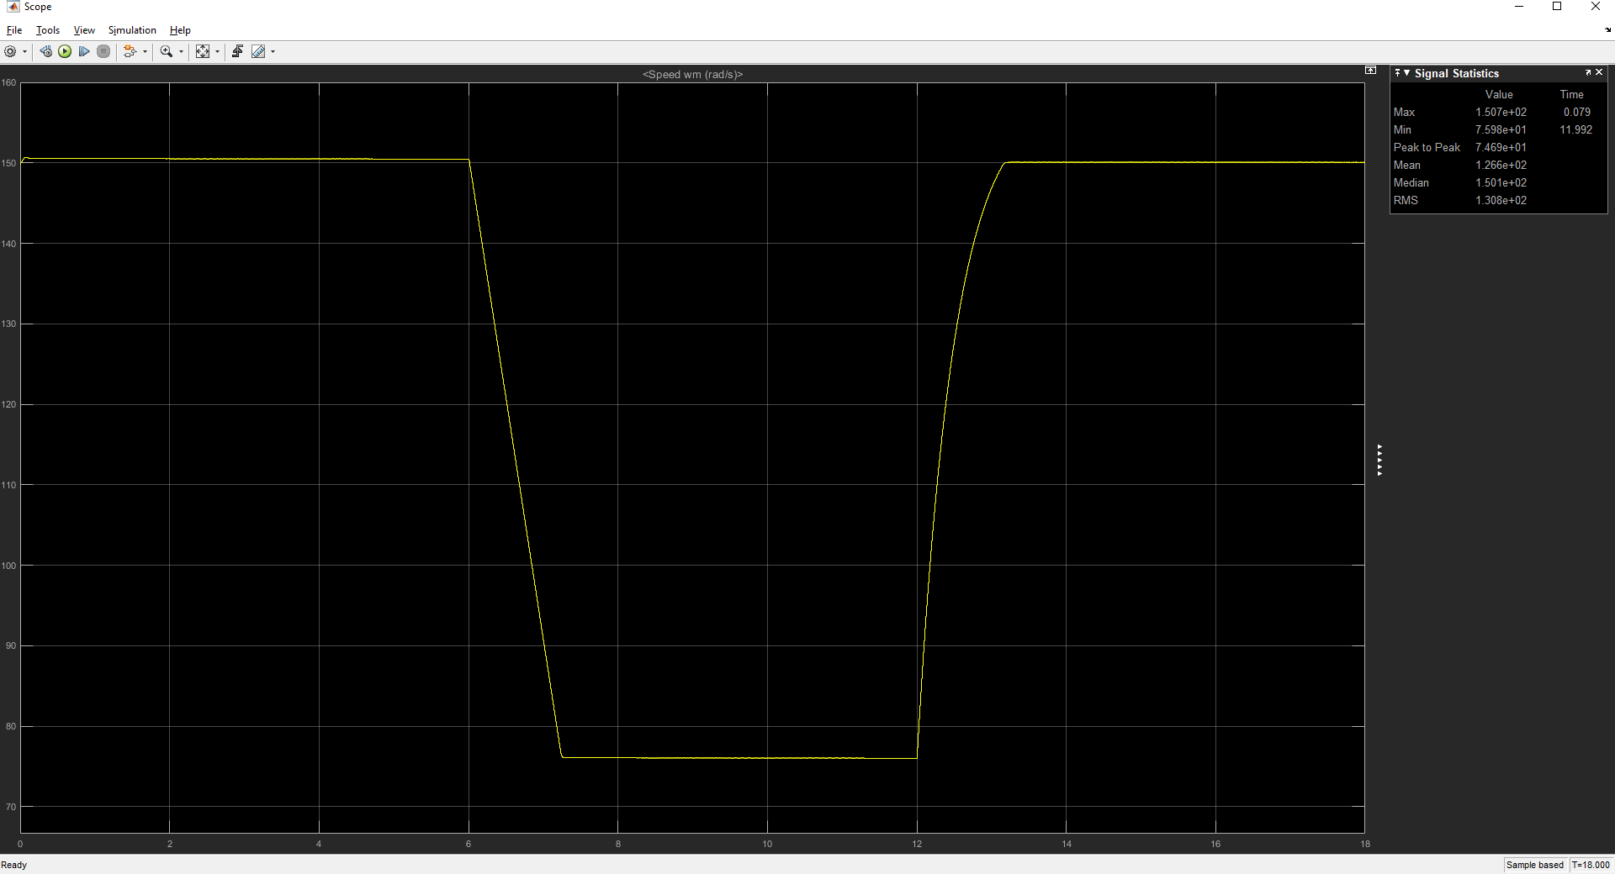

Figure 3: Speed (rad/sec) waveform.

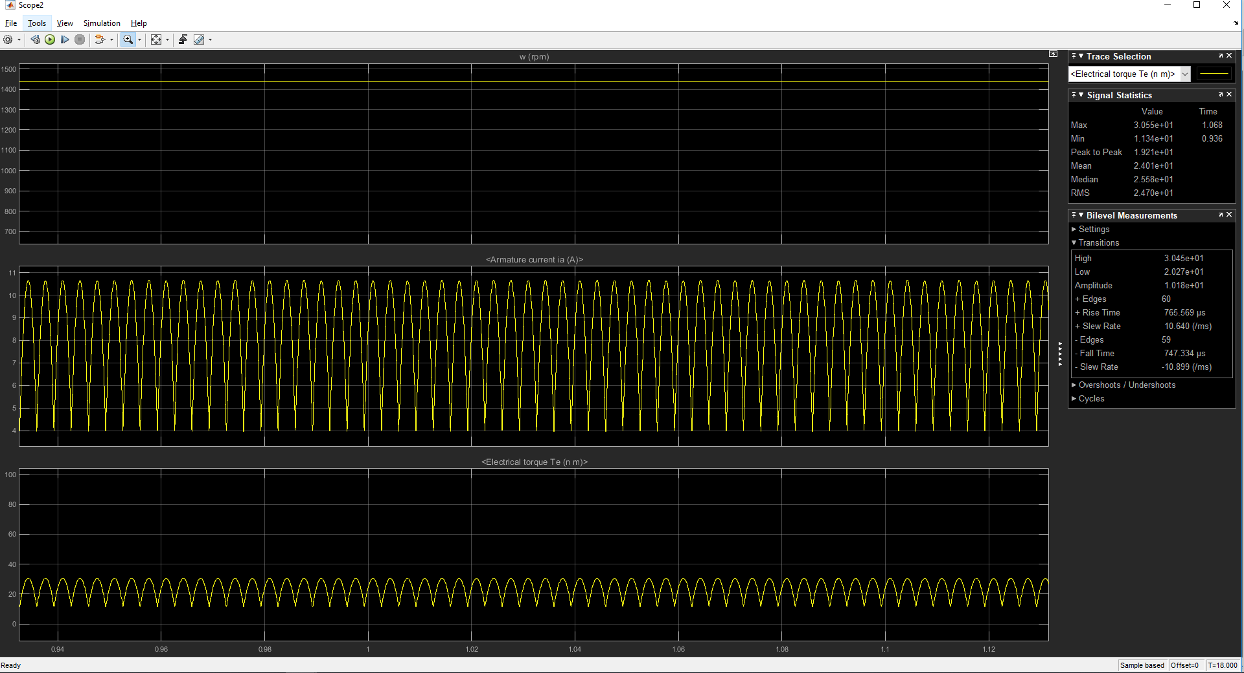

Fgiure 4: Steady-state waveforms at a speed of 150 rad/sec.

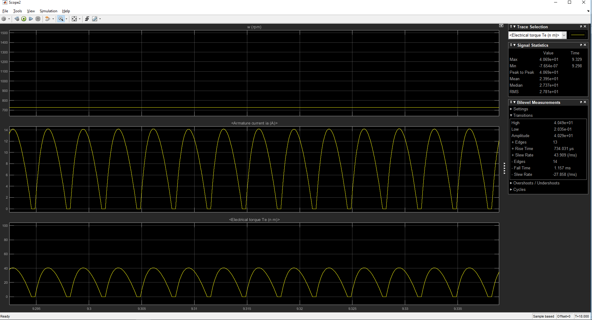

Figure 5: Steady-state waveforms at a speed of 75 rad/sec.

The first observation is that as the flux is constant (because of the permanent magnet), the torque is proportional with the armature current. The armature current becomes 0 when our motor starts to decrease its speed. In this part of the simulation, thrystor rectifiers becomes closed. After reaching the desired value, the switching will start again in order to keep the speed value constant. Secondly, the armature current reachs a peak when the desired speed becomes 150 rad/sec again. In order to speed up the motor quickly, we observed a quick rise in the armature current.

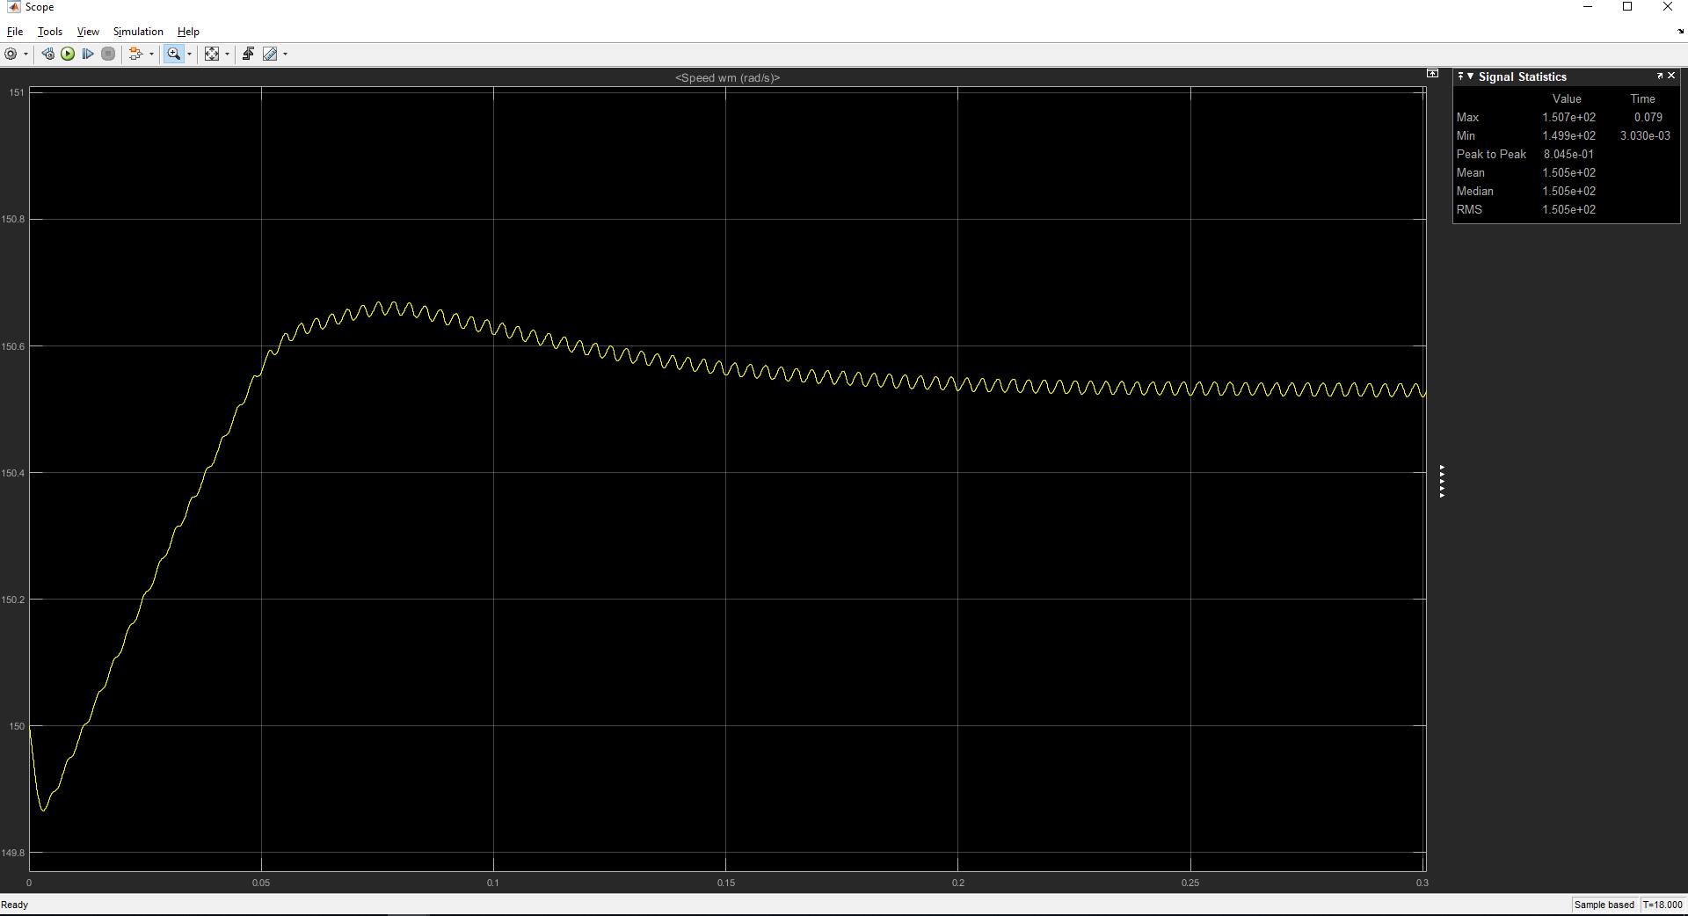

Figure 6: First behaviour of the motor at starting.

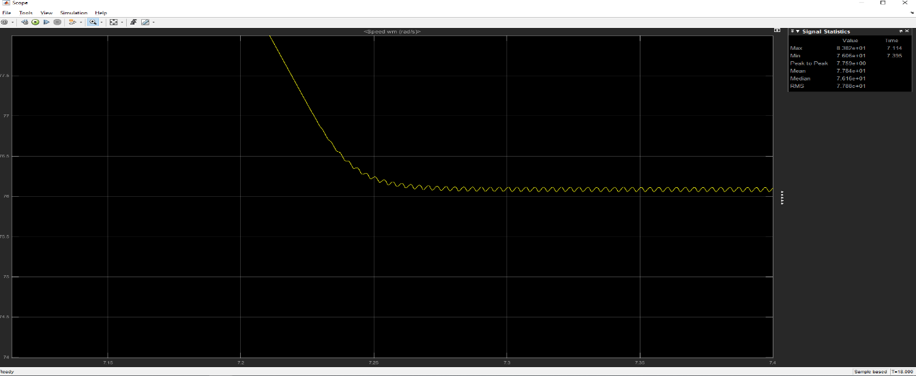

Figure 7: First speed change behaviour from 150 to 75 rad/sec.

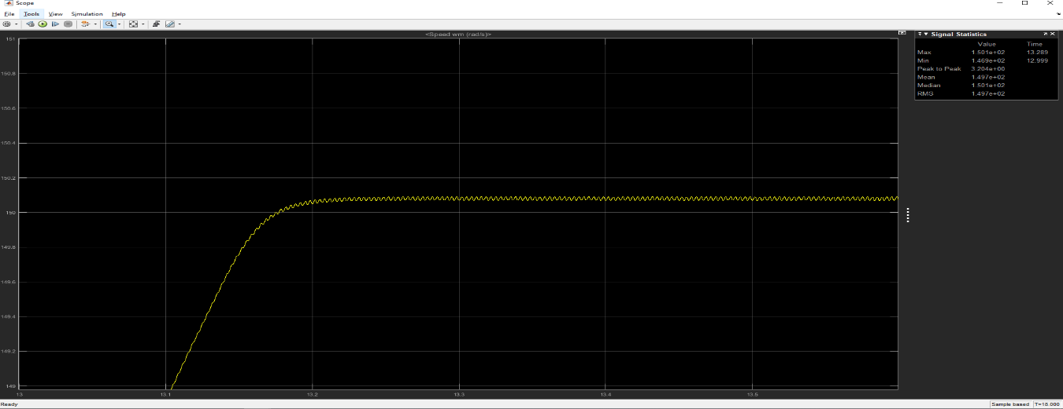

Figure 8: Second speed change behaviour from 75 to 150 rad/sec.

The second important part is the PI controller. In order to get maximum efficiency, parameters of the controller should be arranged correctly. The figures belows shows two different behaviours for different Kp and Ki values.



Figure 9: Waveform when Kp=30 and Ki=0.5.

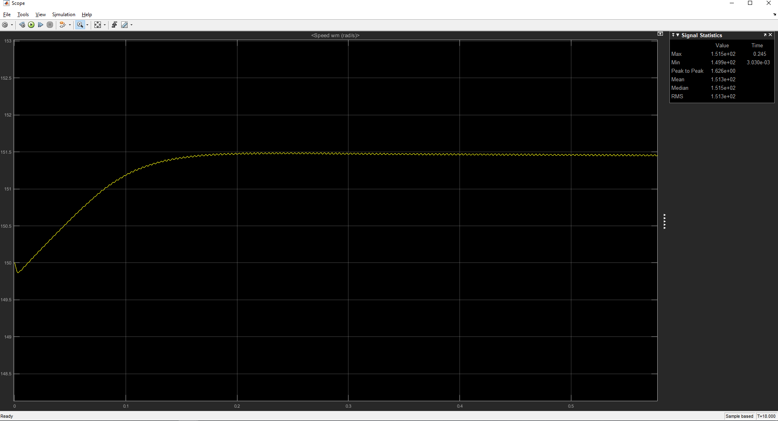

Figure 10: Waveform when Kp=10 and Ki=0.2

Although these values have positive effects on the response, they have a tradeoff. For example, if Kp value is increased, there will be a decrease in the steady-state error. However, overshoots will increase. For Ki value, if it is increased, settling time and overshoots will increase, too. By trial and error method we selected a suitable Kp and Ki values in order to get best performance.

Q2)

In this question the task is designing a Buck converter with the following specs: Vin=56V Vout=28V Rload=4Ω . The schematic of the circuit is in Figure 11. The parameters of the circuit are:

Line inductance=10mH

Shunt capacitances=330uF

Switching frequency=25kHz

The first important parameter is the line inductance. It is directly related with the current ripple by the formula:

The commercial inductance selected for this task has a Mouser No: PA4416NL

Secondly shunt capacitaces are used in order to decrease the voltage ripples. The Mouser Code of the capacitor is EEH-ZK1V331V.

In order to obtain the switching mechanism we used a MOSFET. The Mouser code of the MOSFET is 512-FDD24AN06LA0F085

The cost of the components are respectively 8,93 €, 2,45 € and 0,908 €. The total cost is 12,288 €.

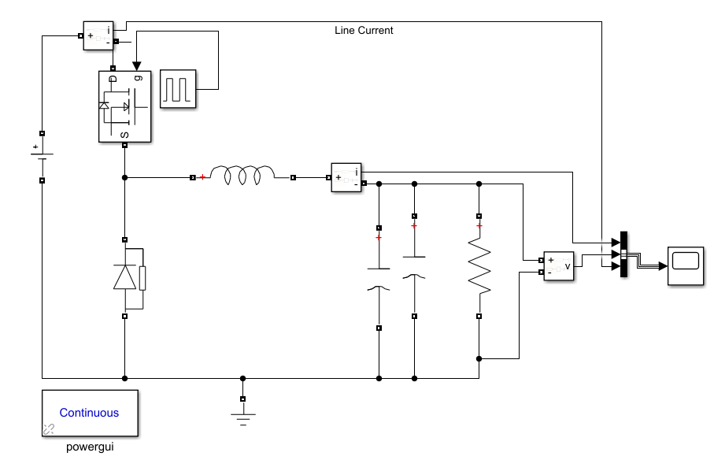

Figure 11: Circuit schematic of Buck converter.

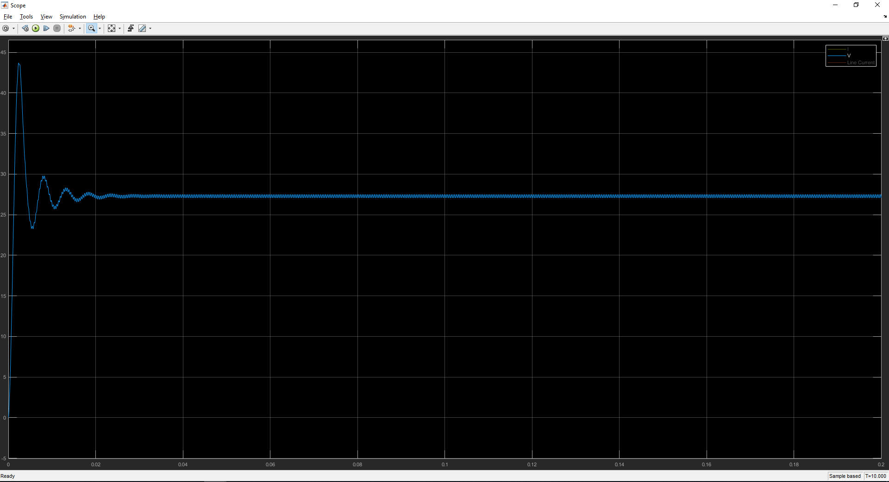

Figure 12: Output voltage waveform without a controller.

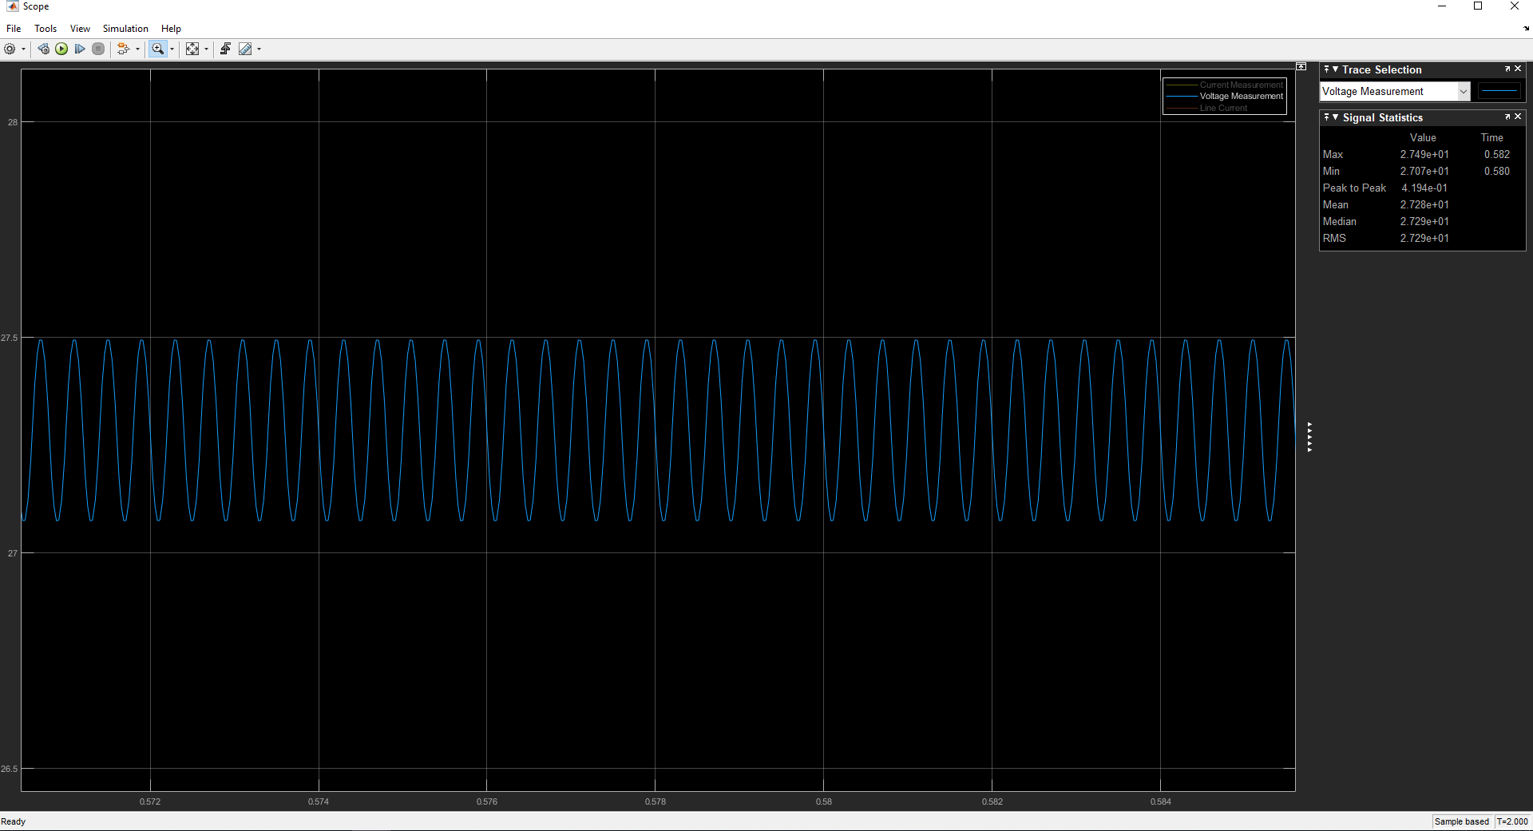

Figure 13: Voltage waveform at steadt-state.

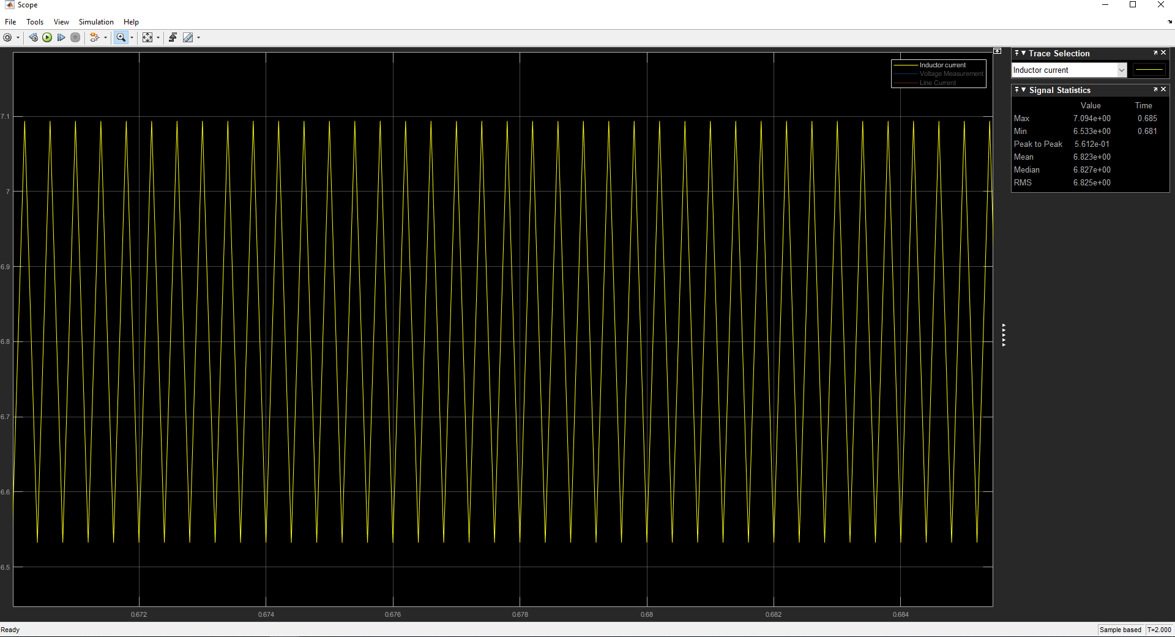

Figure 14: Inductor current at steady-state.

In order to get 28V at the output, the duty cycle of the pulse generator is set as %50. However, due to the losses in the circuit, the average voltage at the output becomes 27,28V. Also the voltage ripple is %1,94 and the current ripple is %8.37.

To get a average voltage near 28V, we should increase the duty cycle of the pulse generator. Figure 15 shows the voltage waveform at steady state when %51.4 duty cycle is applied.

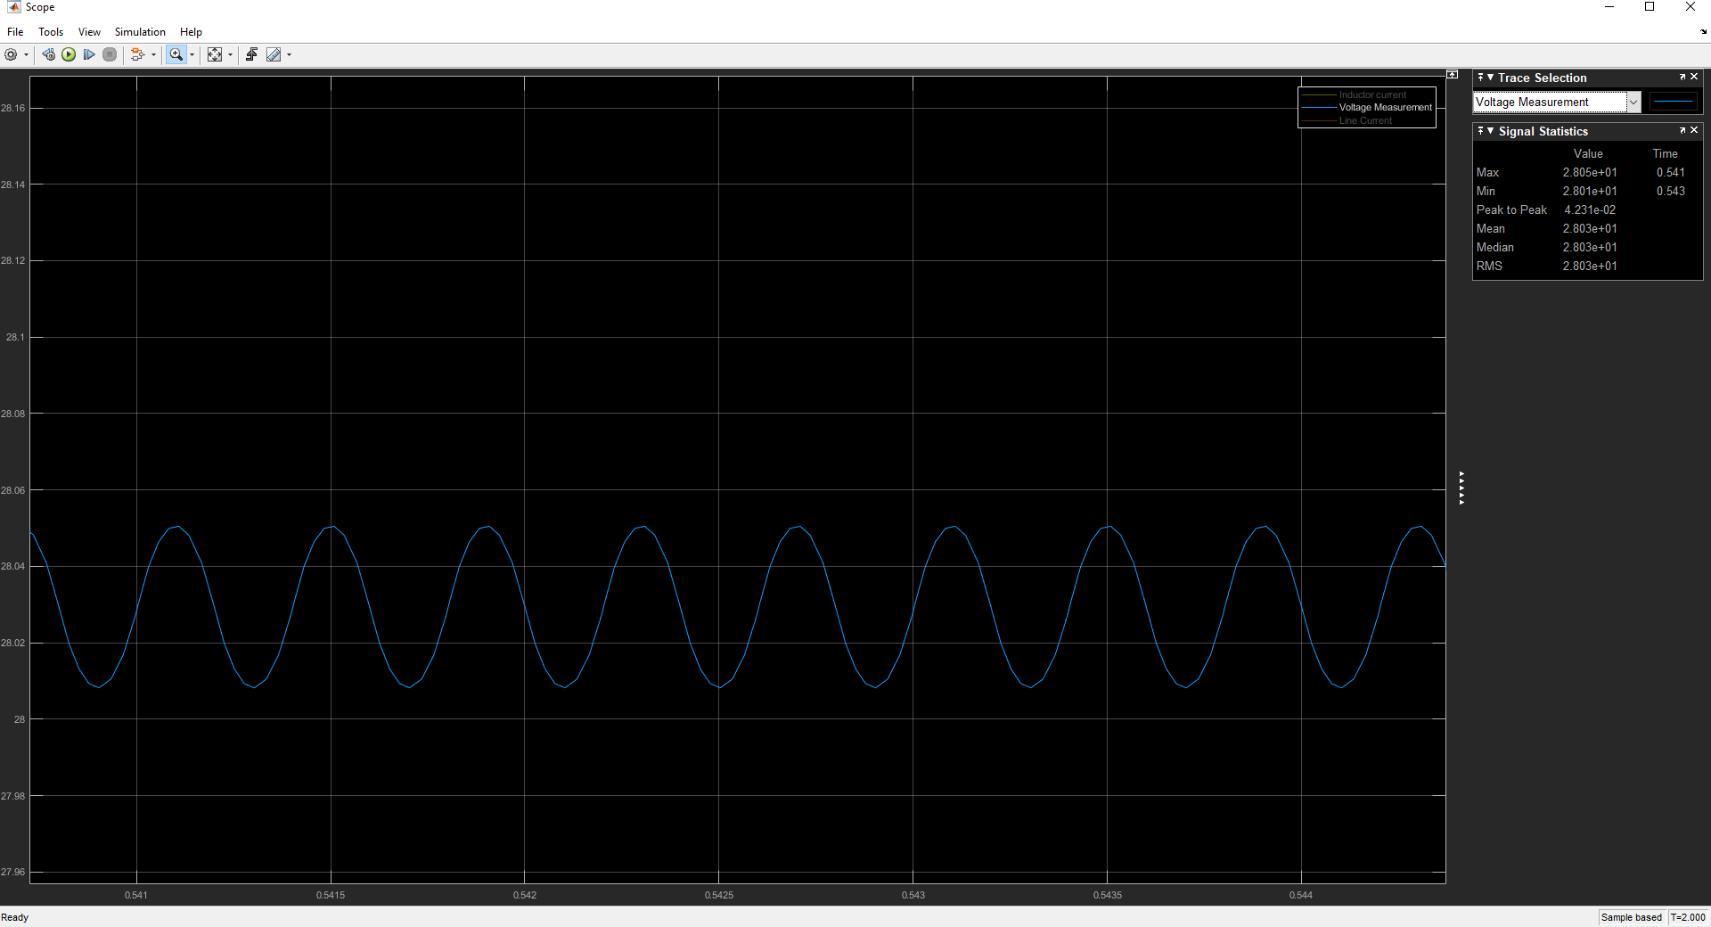

Figure 15: Voltage waveform at steady-state when %51.4 duty cycle is applied.

In order to get more precise results, we added a PID controller which gives the output to PWM generator. The new schematic of the circuit is in Figure 13.

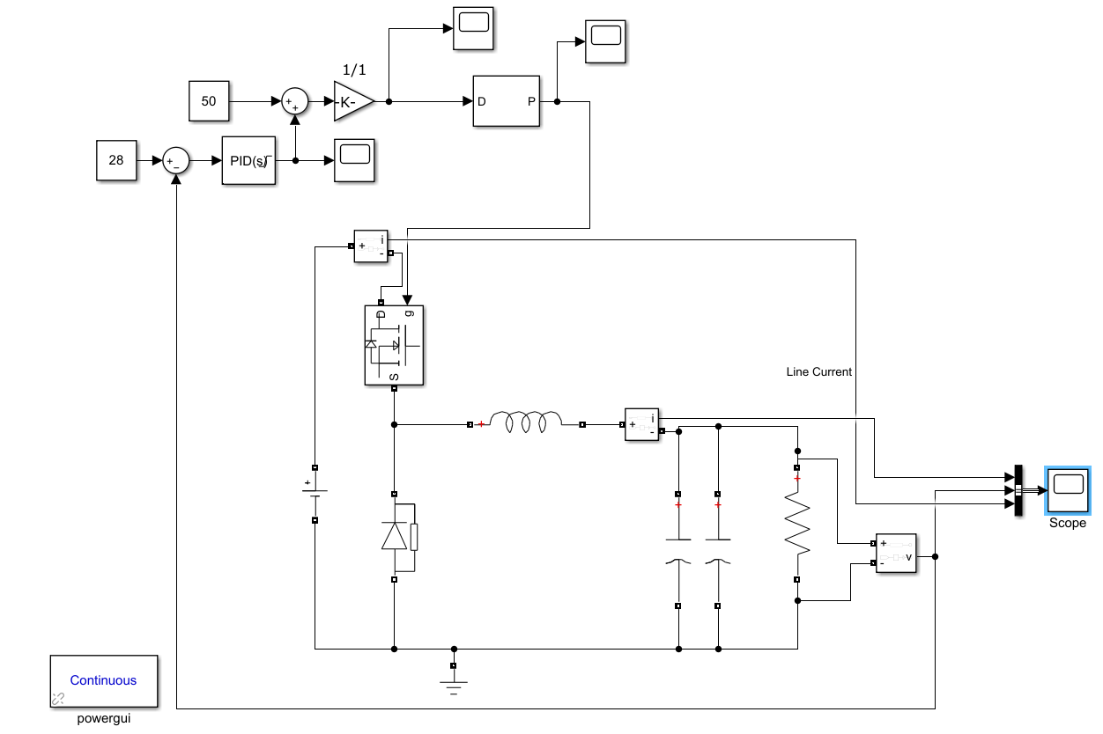

Figure 16: Buck converter with PID controller schematic.

We set the output upper limit of the PID controller as 10 because %50 duty cycle is not enough to get 28V and %60 duty cycle gives the output voltage higher than 28V. The input of the PWM generator should be between 0 and 1. So we divided the value to 100. After arranging the PID parameters the output voltage becomes as in Figure 14.

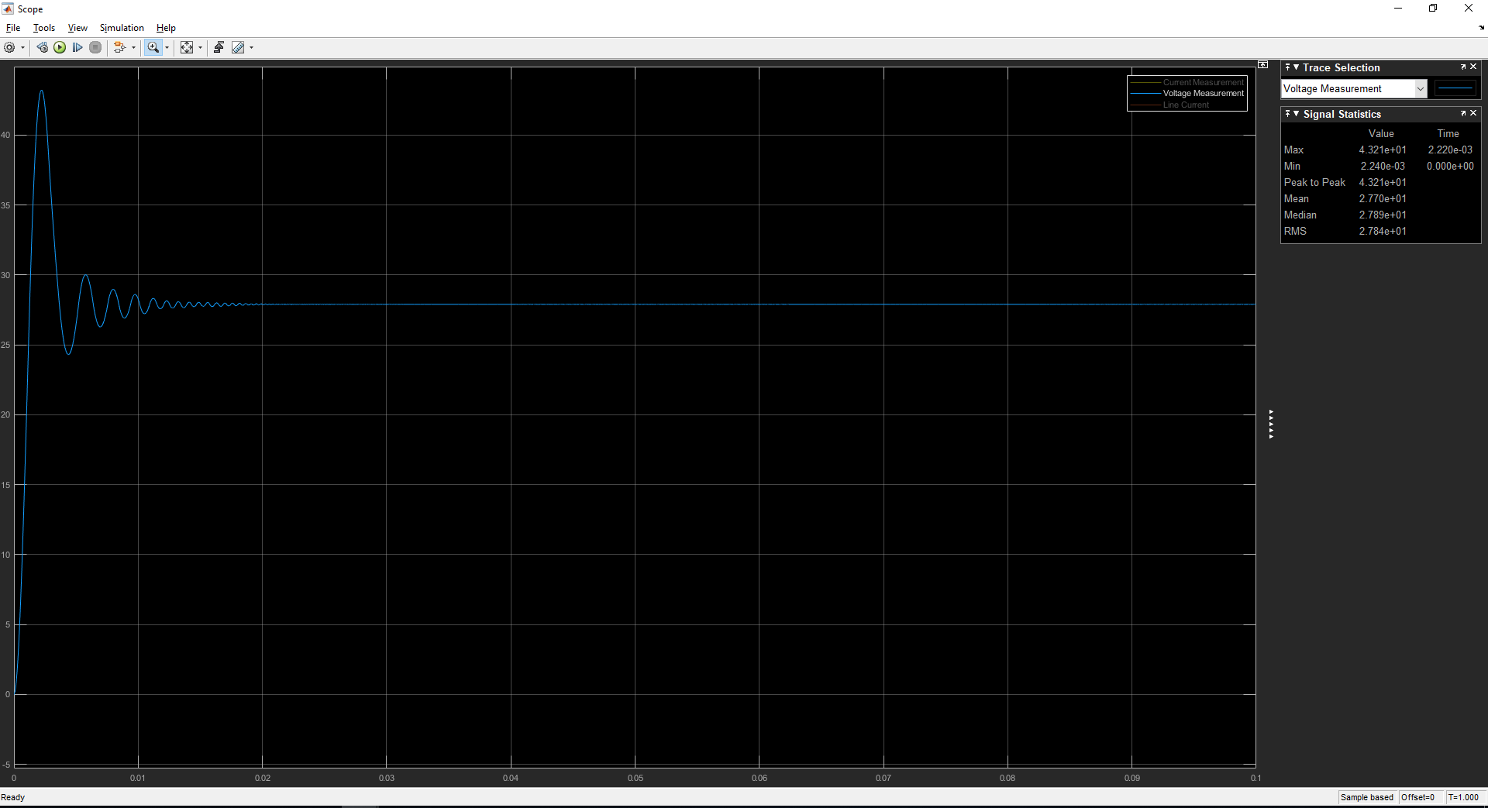

Figure 17: Voltage waveform after PID controller.

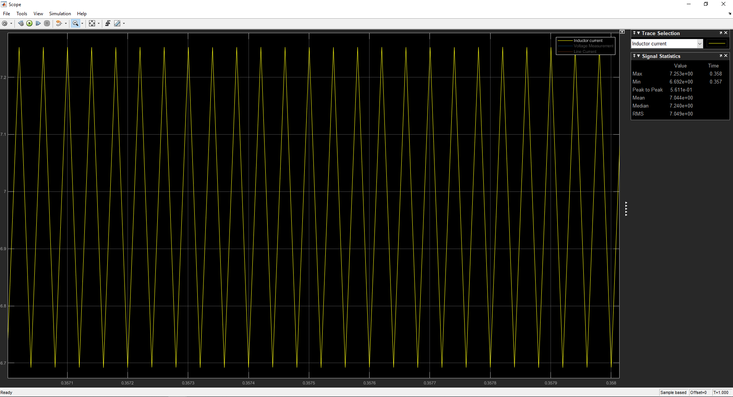

Figure 18: Output current waveform at steady-state.

After the controller, the average output voltage value becomes 27.89V, the voltage ripple becomes %0.014 and the inductor current ripple becomes %7.94.

The input and output power graphs are as follows.

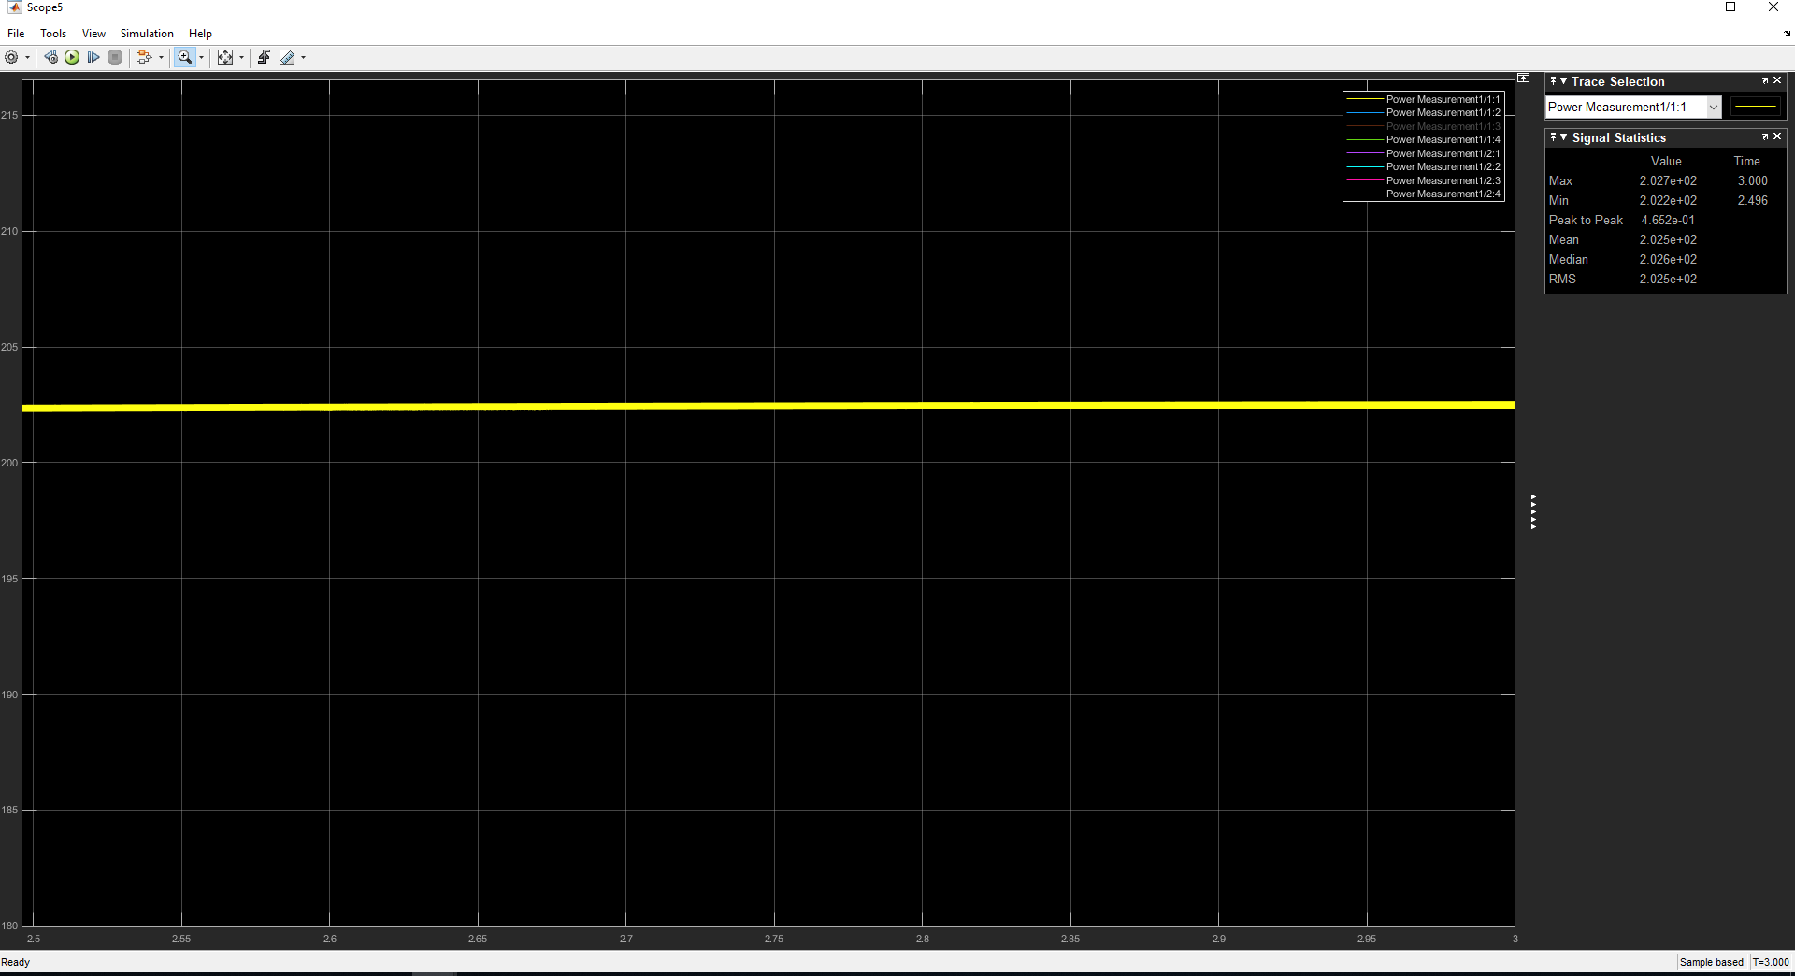

Figure 19: Input power graph.

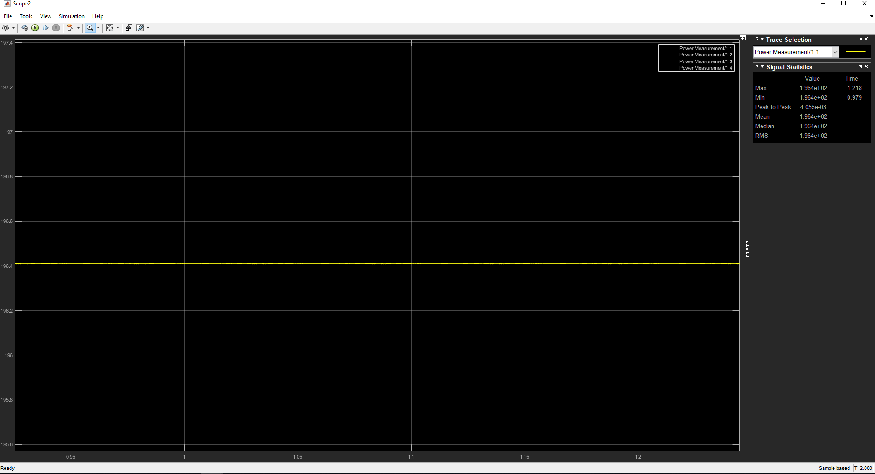

Figure 20: Output power graph.

The efficiency of the converter is :

The losses are due to the switching losses and the losses due to the circuit elements like capacitor, inductor and diode. Moreover, the internal resistance of the MOSFET also has an effect on the losses.